Serverless Iot Data Processing

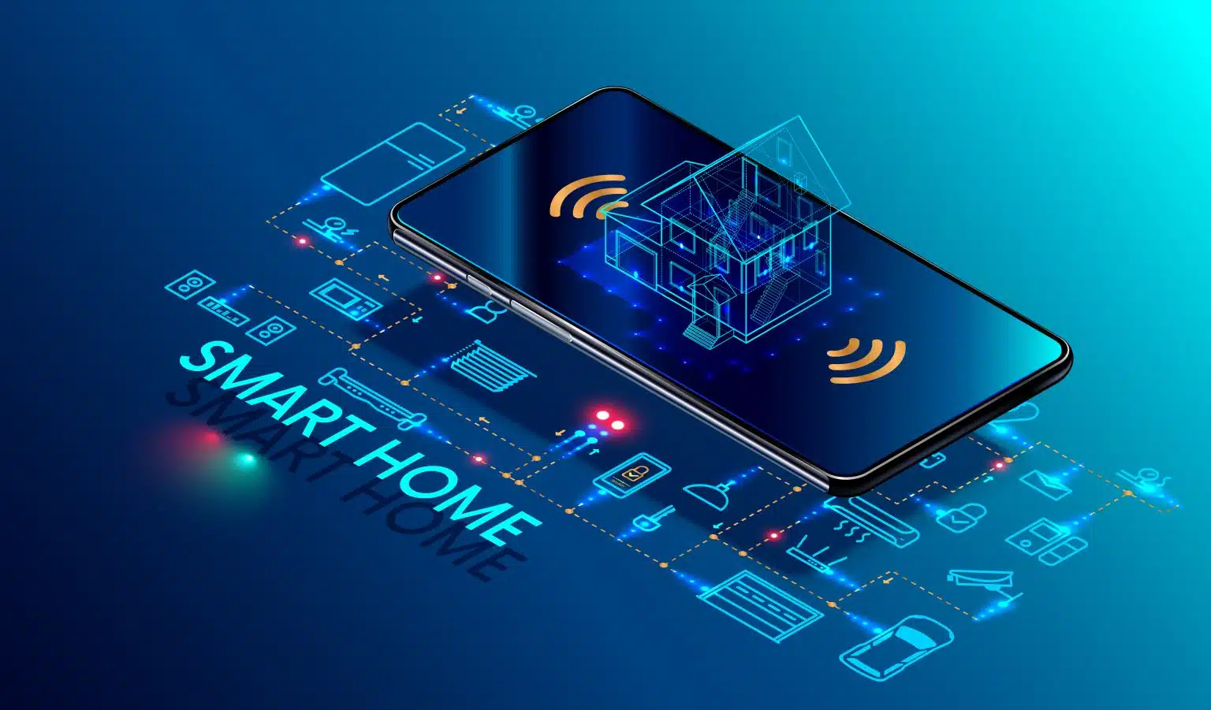

***Submitted by***

N.RAVICHANDRAN

S.NAVEEN

A.RAGUL

G.V.RAMANAN

1. MESHACH IMMANUAL

***Introduction***

Project Tittle :

ServerLess Iot Data Processing Using

Transforming Home into Smart living space in IBM cloud.

Project Objective : project to transform a Home into a smart

living space using IBM cloud functions for Iot data processing is to create

an environment that leverages technology to enhance energy efficiency

and home security.

Project Overview :

Define The Problem : Clearly define the problem

you want to solve with your Iot data processing system understand the

data sources,types of data and specific use cases for this data.

User Requirements : Identify the needs of requirements

of the end user,such as data analysts,engineers or decision makers,who

will interact with the processed data.

Data Transformation And Processing : Identify

the data processing requirements,such as data validation,filtering,

validation,filtering,aggregation or real-time analytics.

Data Storage : Choose the right data storage solutions

for your processed data,considering factors like data volume and access

Patterns.

Security And Authentication : Implement robust

security measures to product data in transit and at rest.Setup access

controls and IAM policies for your serverless functions and data storage.

Key Component :

Data Ingestion : Data ingestion methods and protocols

suitable for your Iot devices(e.g.,MQTP,HTTP,CUSTOM APIs).

Serverless Data Ingestion : Create serverless

function using platform like AWS lambda or azure functions to handle

incoming data .serverless functions to executes when new data is

Received.

Real-Time Analytics : To monitor real time

visualized data.you can use service like AWS kinesis or azure stream

Analytics and power bi ti gain insights from the processed data.

Cost Optimization : Continuously analyze your cloud

costs and optimize your serverless architecture to minimize

expenses.consoder using cost estimation tools provide by tour cloud

Provider.

Development And Deployment : Document the entire

architecture including deployment instructions,configurations and code.

Deploy the system in a cloud environment of your

choice (e.g.,Azure,Google Cloud) and ensure it is well documented for

future maintenance.

Design Thinking Process :

User-Centered Design : Conducted user research

to understand user needs and preference.

Utilized feedback to shape project objectives.

Ideation and Prototyping : Generated

innovative ideas for device integration, data processing, and automation.

Developed prototypes and gathered user feedback for refinement.

Iterative Development : Continuously

improved the system based on user input and testing results.

Ensured that the final solution addresses real-world user

requirements effectively.

Development Phases

Phase 1: Planning and Requirements Gathering

Conducted user interviews and surveys to identify

user needs. Outlined project objectives and key features.

Phase 2: Device Selection and Integration

Selected smart devices including thermostats, cameras,

and sensors.Integrated devices into the smart home network.

Phase 3: Serverless Architecture Design

Chose AWS Lambda as the serverless platform.

Designed serverless functions for data processing and automation.

Phase 4: Real-Time Data Processing :

Implemented data ingestion and processing functions.

Cleaned and analyzed incoming data in real-time.

Phase 5: Automation Routine Development :

Developed rule-based and machine learning-based

automation routines.Automated device control for energy optimization.

Phase 6: Cloud Data Storage Setup :

Utilized AWS S3 for long-term data storage.

Integrated DynamoDB for structured data storage.

Phase 7: Testing and Optimization :

Conducted extensive testing to ensure system

reliability.Optimized code and serverless configurations for performance.

PROGRAMS FOR SNIPPETS :

Data Ingestion (AWS Lambda and Python)

```python

import boto3

import json

def lambda_handler(event, context):

# Ingest data from IoT devices

data = json.loads(event['Records'][0]['SNS']['Message'])

# Process the data

process_data(data)

def process_data(data):

# Implement data processing logic

# (e.g., data filtering and analytics)

Pass

```

Automation Routine (Python)

```python

def automate_light_control(room_occupancy, light_status):

if room_occupancy == "empty" and light_status == "on":

# Turn off lights when the room is empty

turn_off lights()

def turn_off_lights():

# Implement device control logic to turn off lights

pass

```

Cloud Data Storage (AWS S3 and Python)

`` python

import boto3

def upload_data_to_s3(data, object_key):

s3 = boto3.client('s3')

s3.put_object(Bucket='your-bucket-name',

Key=object_key, Body=data)

def retrieve_data_from_s3(object_key):

s3 = boto3.client('s3')

response = s3.get_object(Bucket='your-bucket-name', Key=object_key

data = response['Body'].read()

Return data

***Conclusion*** :

*In conclusion, the "Serverless IoT Data Processing for*

*Smart Home" project represents a comprehensive solution for creating a*

*cutting-edge smart home environment. By combining user-centered*

*design, serverless architecture, real-time data processing, automation,*

*and cloud-based storage, we have achieved a system that enhances user*

*comfort and security while optimizing energy usage.*

*This project showcases the potential of serverless IoT data*

*processing and its applicability to real-world scenarios. We look forward*

*to the opportunity to further develop and expand this solution for broader*

*adoption in the smart home industry.*